**PRACTICAL-1**

**AIM: Write a C program to identify whether a given line is valid comment or not.**

**CODE:**

#include<stdio.h>

#include<conio.h>

#include<string.h>

void main()

{

char com[30];

int i=2,a=0;

clrscr();

printf("\n Enter comment:");

gets(com);

if(com[0]=='/')

{

if(com[1]=='/')

printf("\n It is a comment");

elseif(com[1]=='')

{

for(i=2;i<=strlen(com);i++)

{

if(com[i]==''&&com[i+1]=='/')

{

printf("\n It is a comment");

a=1;

break;

}

else

continue;

}

if(a==0)

printf("\n It is not a comment");

}

else

printf("\n It is not a comment");

}

else

printf("\n It is not a comment");

getch();

}

**OUTPUT:**

Test-Case 1:

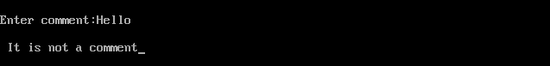

Test-Case 2:

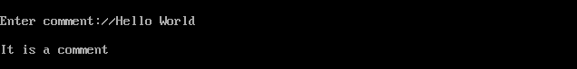

Test-Case 3:

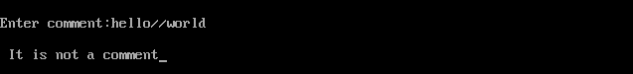

Test-Case 4:

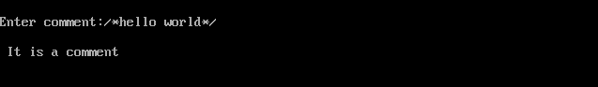

Test-Case 5:

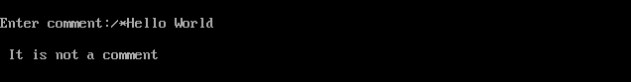

Test-Case 6:

